**Front End**

**\* Mandatory Field**

**^ Hidden On UI (Never visible)**

**~ Do not show to user by default. Need to show in different section when user want to enter more details. This is to keep UI simple.**

# UI Design Principal:

* UI will be kept simple by showing only required field for creating various objects, if user want to add more details he can click on “Advanced” or similar link/button on the form.
* Static Items/Objects used which may used frequently or multiple times will be stored in the cache.
* UI will always function in a context of a particular orgainzation (logged in user’s organization). Cross organization data should never be visible or accessible.
* Whereever date is applicable show the calender menu and also populate the current date for data entry ease.
* All the UI lables/messages prompts should be internationalized, i.e the UI should support multiple languages and for that instead of actual lable/message, a key will be used as a placeholders.

|  |  |
| --- | --- |
| **Important / Global Object** | **Description/Design** |
| CreatedById | * Logged in Employee ID * Store in the mobile app cache. * Hidden on Mobile UI * Need to pass to almost all API |
| OrgID | * Logged in user’s Organization Id * Store in the mobile app cache. * Hidden on Mobile UI * Need to pass to almost all API |
| City | * List of Cities * Store in the cache |
| Customer | * Customer table for the logged in user’s organization will be cached for faster search. |
| ExpenseCategory | * List of Expense Category * It will be cached. |
| ToAccountID | * List of To Accounts, will be cached |
| SelfAccount | * A default account for self will be cached |

# Customer

|  |  |
| --- | --- |
| **Fields** | **Explaination** |
| Name* | TextField – Free Form |
| City* | List 🡪 Auto Search List  (From predefined list)  The list should be stored in the Cache |
| Mobile | TextField (15 Char) |
| p Number |  |
|  |  |
| GST Number~ | TextField (20 Char) |
| Transporter~ | Text Area (256 char) |

**Operation Required:**

Create, Update, Search ( On the basis of Name and City)

# Delivery

|  |  |
| --- | --- |
| **Fields** | **Explaination** |
| Delivery Date | Date Field |
| Customer Name | Text Field  Auto type search field  Get the CustomerId from CustomerName |
| Description |  |
| Org ID^ | Get Automatically from current context in user |
| CreatedByID^ | Hidden  Get Automatically from logged in user |
| CustomerID^ | Retrieved as a result of Customer Name serach. |

**Operation Required:**

Create

# Customer Billing

|  |  |
| --- | --- |
| **Fields** | **Explaination** |
| Customer Name | Auto Type Search |
| CustomerID^ | Hidden, retreived as a result of customer name search |
| Date | Current Date Auto Populate |
| Order Amount | Number |
| Total | Number (Read Only (Non Editable))  Auto calculated as soon as value in the dependent field entered  Value will be sum of following fields (number field will default to 0) :   * Order Amount * CGST * SGST * IGST * EXTRA |
| CGST~ | Number |
| SCGST~ | Number |
| IGST~ | Number |
| Extra~ | Number |
| Include In Calculation~ | Checkbox (Default Checked) |
| IncludeInReport~ | Checkbox (Default Not-Checked) |
|  |  |
| Notes~ |  |
| OrgID^ |  |
| CreatedByID^ |  |

# Expense

|  |  |
| --- | --- |
|  |  |
| Expense Date: | Auto Populated : Current Date |
| Expense Category: | Static List coming from Expense category API |
| Expense Description: | Free Text Field (150 Char) |
| Expense Amount : | Number |
| To Account | Static List  Default to SELF |
| ToAccountID: | Returned from To Account Field. |
| To Party Name: | If “Category = Deposit” other than this then Free Text Field else  If Deposit: It will be Name of internal employee |
| Org Id: ^ |  |
| Notes ~: | Free Text Field (250 Char) |
| CreatedByID ^: |  |
| FromAccountID: | List of SELF Account  One person can have multiple accounts |
|  |  |
|  |  |
| CGST~ | Number |
| SCGST~ | Number |
| IGST~ | Number |
| Extra~ | Number |
| Include In Calculation~ | Checkbox (Default Checked) |
| IncludeInReport~ | Checkbox (Default Not-Checked) |

# Vendor

Vendor ID – Auto Generated By App

Vendor Name - Free Text

Vendor City : Pull from Predefined list of citities

Vendor Phone Number:

# Employee

* Employee Name
* Employee Id
* Employee Role (Map to “User Role”)
* Employee Type (Main, Labour)
* FingerPrint

# Direct Data Load in MySQL ( No need to maintain from code)

**Expense Category:**

* Machine Parts Purchase
* Machine Maintenance
* Transporting / Courier Charges
* Non-Company Related
* Deposit
* Vendor Payment
* Misc
* Marketing

**List of Citites**

* Barufatak
* Dhamnod
* Thikri
* Khargone
* Badwani
* Rajpur
* Indore
* Rau
* Pithampur
* Mandleshwar
* Bistan
* Lohari

**User Roles**

* Production Manager
* Operations Manager
* Accounting
* Sales Lead
* Admin

**Function**

* *Create Employee*
* Update Employee
* Create Customer
* Update Customer
* Delete Customer
* Create Expense
* Update Expense

**Time Tracking**

* Date
* Login Time
* Logout
* Employee ID

# UI Forms

## Login

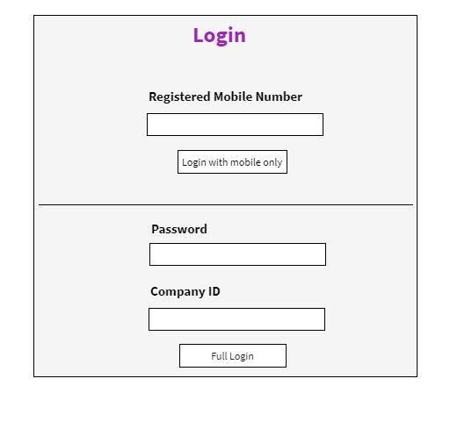

|  |  |  |
| --- | --- | --- |
| **Field** | **Validations** | **On Action** |
| Registered Mobile Number | Not Empty and 10 digit mobile number | Full Login |
| Password | Not Empty |
| CompanyID | Not Empty |

|  |  |  |
| --- | --- | --- |
| **On Action** | **What to do** | **API to use** |
| Full Login | Validate Mobile Number and password is correct for given Company ID |  |

Future Screen (Not to be developed now)

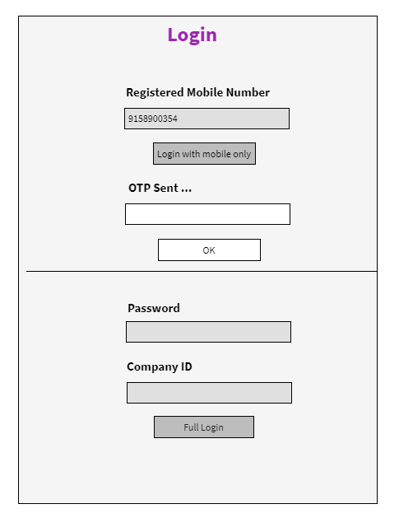

## Dashboard

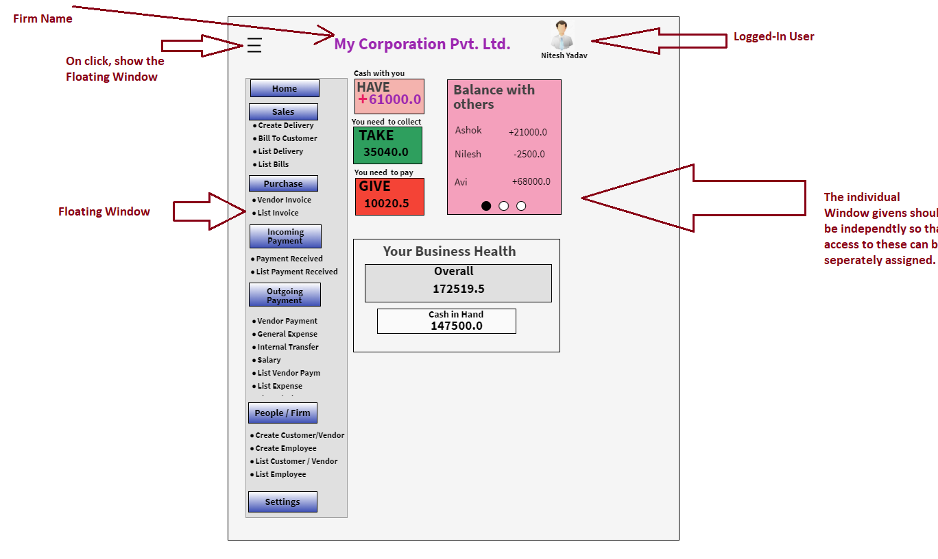

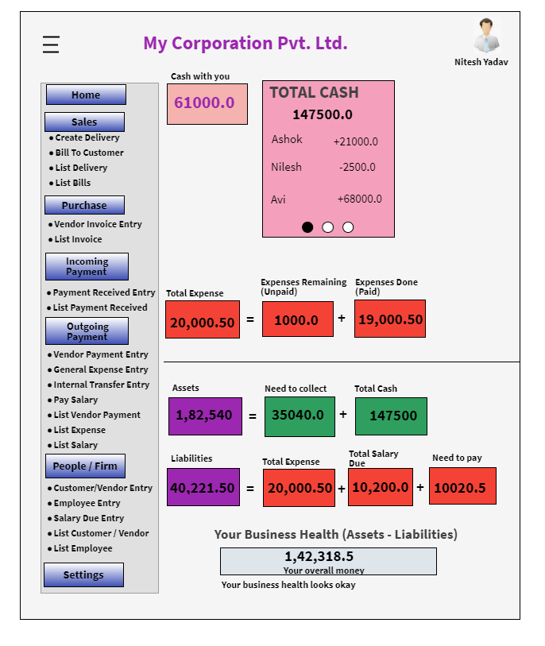

Floating Panel

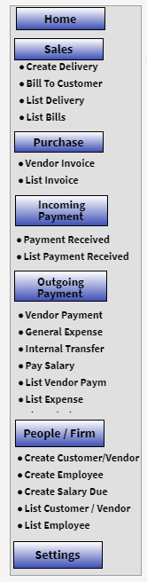

## Create Customer

We will show basic form if end-user want to see more fields then he/she will click on “Advanced”

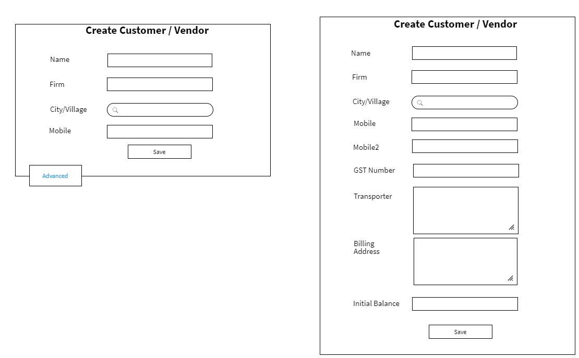

|  |  |  |
| --- | --- | --- |
| **Field** | **Validations** | **On Action** |
| Name* | Not Empty – atleast 2 characters | Save |
| City/Village * | Not Empty  Auto Type Search – after two characters |
| Mobile Number* | Not Empty – 10 digit number |
| GST Number | 15 character |
| Mobile2 | 10 digit number |
|  |  |

|  |  |  |
| --- | --- | --- |
| **On Action** | **What to do** | **API to use** |
| City/Village  Type 2 character – auto search | Search City/Village from the list |  |
| Save | Create Customer |  |

## List Customer/Vendor

Full Form will look like following:

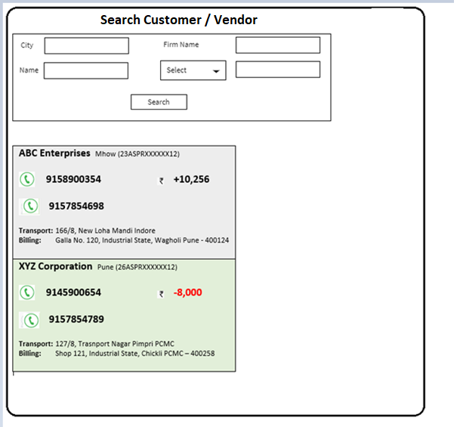

**Search Panel explaination below:**

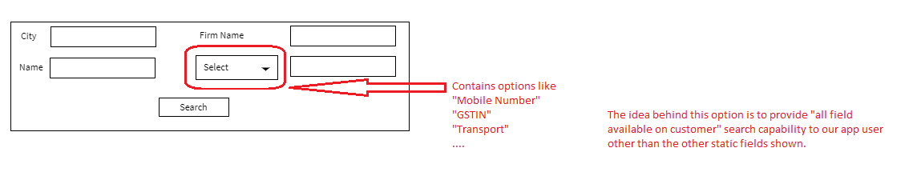

Notes:

If you look at the “Select” field, it gives user a choice of selecting other fields which are not directly available statically. Instead of making all fields “statically” available, here in future we can add more fields.

**List Panel Explaination below:**

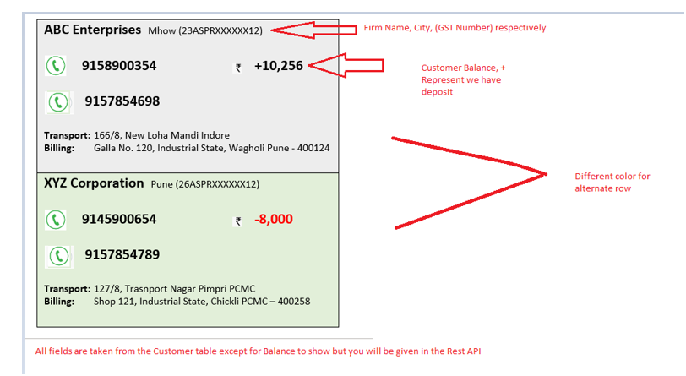

## Delivery Create

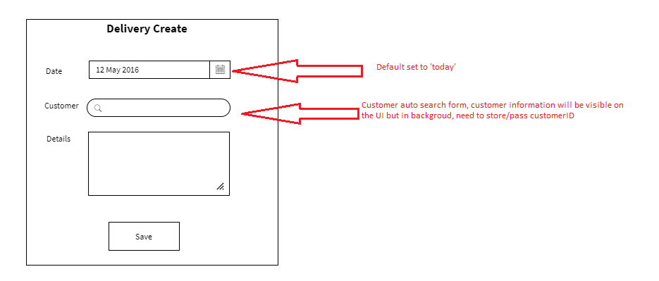

|  |  |  |
| --- | --- | --- |
| **Field** | **Validations** | **On Action** |
| Date* | Not Empty  default “today” | Save |
| Customer * | Not Empty |

|  |  |  |
| --- | --- | --- |
| **On Action** | **What to do** | **API to use** |
| Customer  Type 2 character – auto search | Search City/Village from the list |  |
| Save | Create Delivery |  |

## View/List Delivery

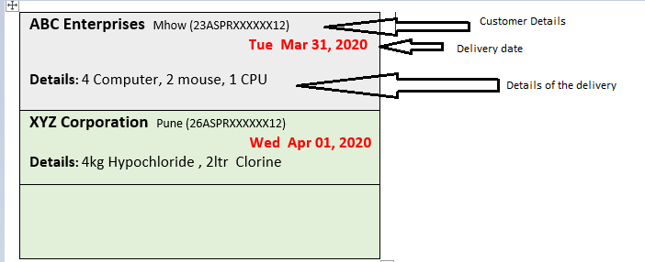

## Purchase Entry/Received-Bill Entry

The form will show basic form fields to create a bill, if a user wants to enter more details:- he can click on “Advanced”

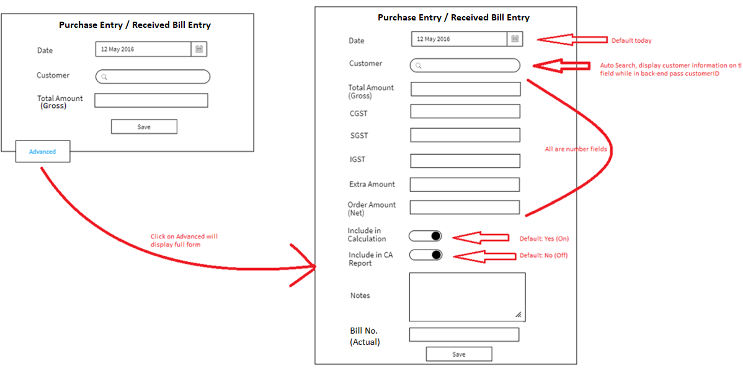

**Mandatory Fields**

Date, Customer,

**Validation:**

Number Validation (cannot be a text) :

|  |  |  |
| --- | --- | --- |
| **Field** | **Validations** | **On Action** |
| Date* | 1. Not Empty 2. default “today” | Save |
| Customer * | Not Empty |
| Total Amount (Gross) | 1.Not Empty  2.Numbers only |  |
| CGST,SGST,IGST, Extra Amount, Order Amount(Net) | If value is present, it is number. |  |

|  |  |  |
| --- | --- | --- |
| **On Action** | **What to do** | **API to use** |
| Customer Search  Type 2 character – auto search | Search Customer’s **account** (not customer actually) |  |
| Save | Create Purchase Entry |  |

## List Purchase Bill

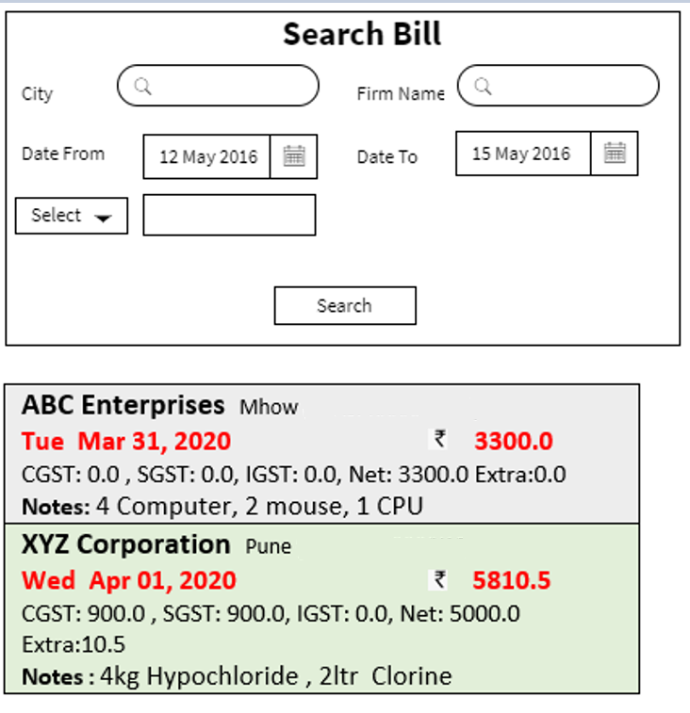

**Search Panel explaination below:**

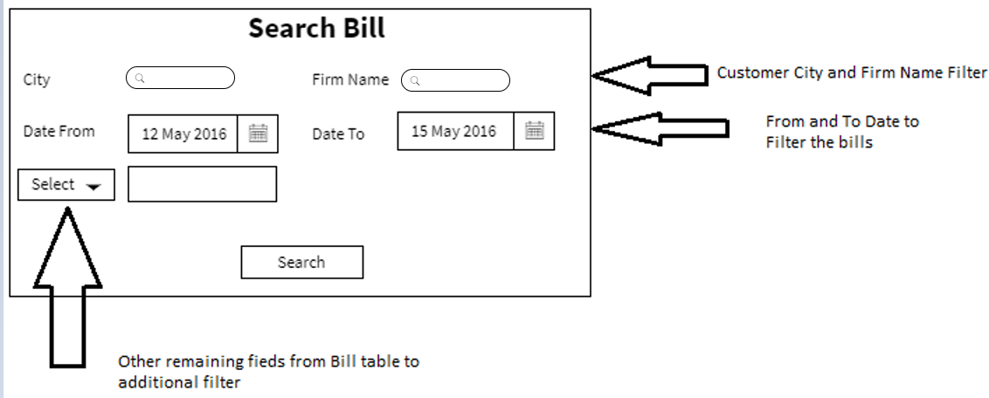

**List Panel explaination below:**

|  |
| --- |
| **ABC Enterprises** Mhow (23ASPRXXXXXX12)  **Tue Mar 31, 2020 3300.0**  CGST: 0.0 , SGST: 0.0, IGST: 0.0, Net: 3300.0 Extra:0.0  **Notes:** 4 Computer, 2 mouse, 1 CPU  **Include in CA Report: Yes**  **Include in Calculation: No**  **Bill No:** **C102** |
| **XYZ Corporation** Pune (26ASPRXXXXXX12)  **Wed Apr 01, 2020 5810.5**  CGST: 900.0 , SGST: 900.0, IGST: 0.0, Net: 5000.0 Extra:10.5  **Notes :** 4kg Hypochloride , 2ltr Clorine  **Include in CA Report: No**  **Include in Calculation: Yes**  **Bill No:** |

## Create Expense

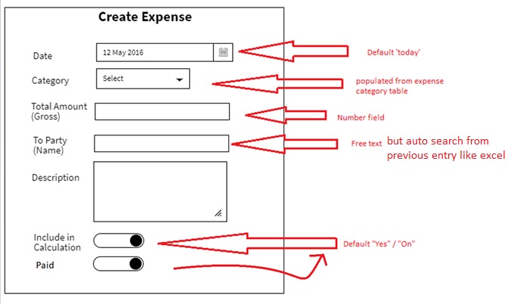

|  |  |  |
| --- | --- | --- |
| **Field** | **Validations** | **On Action** |
| Date* | 1. Not Empty 2. default “today” | Save |
| Category* | Not Empty |
| Total Amount (Gross) | 1.Not Empty  2.Numbers only |  |
| To Party (Name) | Not Empty  Atleast 3 characters |  |
| Include in calculation, Paid | Default “Yes/On” |  |
|  |  |  |

|  |  |  |
| --- | --- | --- |
| **On Action** | **What to do** | **API to use** |
| Category – List | Show Category list |  |
| Save | Create Sales Entry /Create Invoice |  |

## List/View Expense

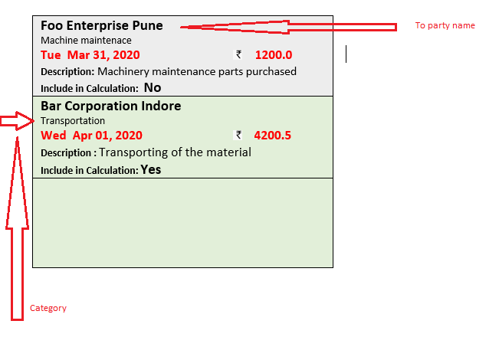

## Create Payment Received

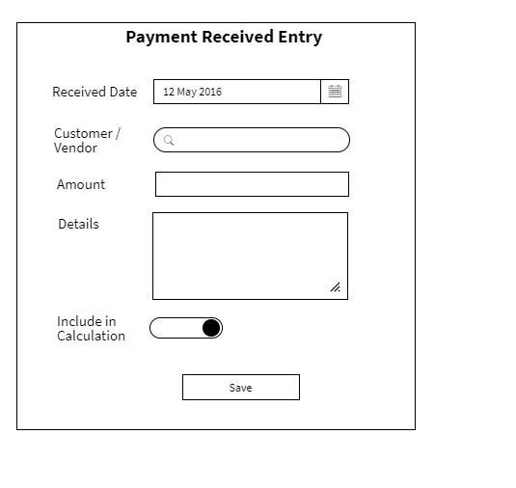

**Mandatory Fields**: Received Date, Customer/Vendor, Amount,

**Hidden Field:**

CreatedById = Logged in User ID

Received By: Account ID

**Populate UI fields:**

Customer/Vendor :

|  |  |  |
| --- | --- | --- |
| **Field** | **Validations** | **On Action** |
| Received Date* | 1. Not Empty 2. default “today” | Save |
| Customer/Vendor | Not Empty |
| Amount | 1.Not Empty  2.Numbers only |  |
|  |  |  |
| Include in calculation | Default “Yes/On” |  |
|  |  |  |

|  |  |  |
| --- | --- | --- |
| **On Action** | **What to do** | **API to use** |
| Customer/Vendor – Search | User Type 2 characters and auto-search starts and shows the list of customer’s accounts  Search on Account instead of Customer/Vendor |  |
| Save | Create a Payment Received |  |

## List Payment Received

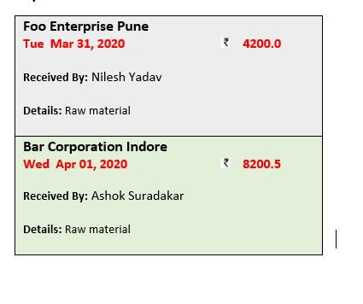

## Sales Entry / Create Invoice

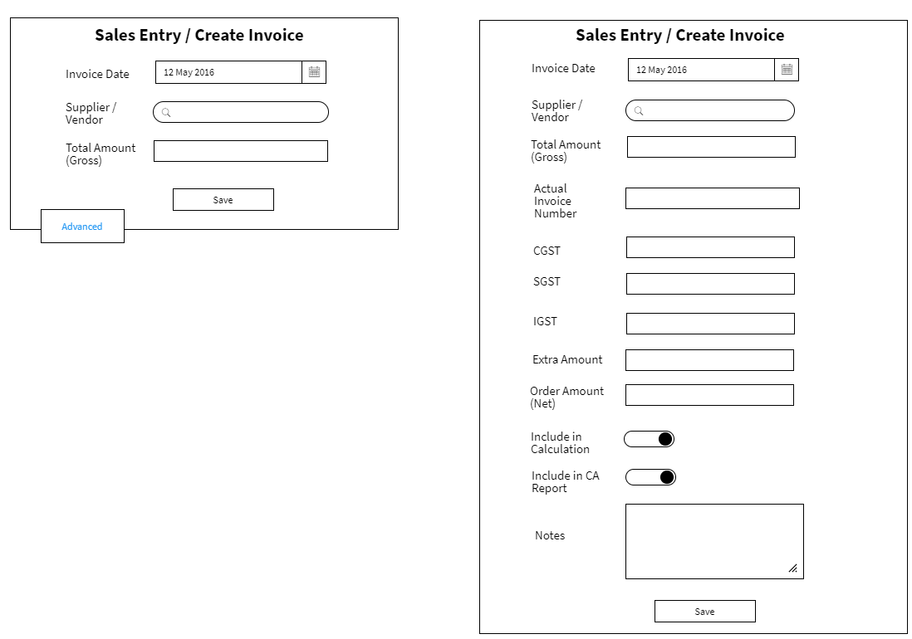

|  |  |  |
| --- | --- | --- |
| **Field** | **Validations** | **On Action** |
| Invoice Date* | 1. Not Empty 2. default “today” | Save |
| Supplier/Vendor * | Not Empty |
| Total Amount (Gross) | 1.Not Empty  2.Numbers only |  |
| CGST,SGST,IGST, Extra Amount, Order Amount(Net) | If value is present, it is number. |  |

|  |  |  |
| --- | --- | --- |
| **On Action** | **What to do** | **API to use** |
| Supplier/Vendor Search  Type 2 character – auto search | Search Customer’s **account** (not customer actually) |  |
| Save | Create Sales Entry /Create Invoice |  |

## List Sales Invoice

|  |
| --- |
| **National Chemical Ltd.** Ahmadabad  **Tue Mar 31, 2020 3300.0**  Net: 3300.0, CGST: 0.0 , SGST: 0.0, IGST: 0.0, Extra:0.0  **Notes:** 4kg Hypochloride , 2ltr Clorine  **Include in Calculation: No**  **Include in CA Report: Yes**  **Bill No: C103** |
| **Aardhya Agro Ltd** Pune  **Wed Apr 01, 2020 5810.5**  Net: 5000.0 , CGST: 900.0 , SGST: 900.0, IGST: 0.0, Extra:10.5  **Notes :** 4 Computer, 2 mouse, 1 CPU  **Include in Calculation: Yes**  **Include in CA Report: No**  **Bill No:** |

## Pay To Vendor

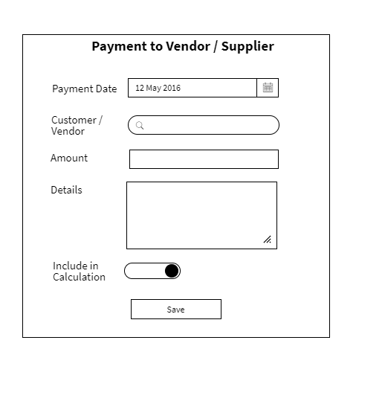

|  |  |  |
| --- | --- | --- |
| **Field** | **Validations** | **On Action** |
| Payment Date* | 1. Not Empty 2. default “today” | Save |
| Customer/Vendor | Not Empty |
| Amount | 1.Not Empty  2.Numbers only |  |
|  |  |  |
| Include in calculation | Default “Yes/On” |  |
|  |  |  |

|  |  |  |
| --- | --- | --- |
| **On Action** | **What to do** | **API to use** |
| Customer/Vendor – Search | User Type 2 characters and auto-search starts and shows the list of customer’s accounts  Search on Account instead of Customer/Vendor |  |
| Save | Create PayToVendor |  |
|  |  |  |

## List Pay To Vendor

|  |
| --- |
| **National Chemical Ltd.** Ahmadabad  **Tue Mar 31, 2020 3300.0**  **Done By:** Nilesh Yadav  **Details:** Raw material |
| **Aardhya Agro Ltd** Pune  **Wed Apr 01, 2020 5810.5**  **Done By:** Ashok Suradakar  **Details:** Raw material |

## Internal Transfer

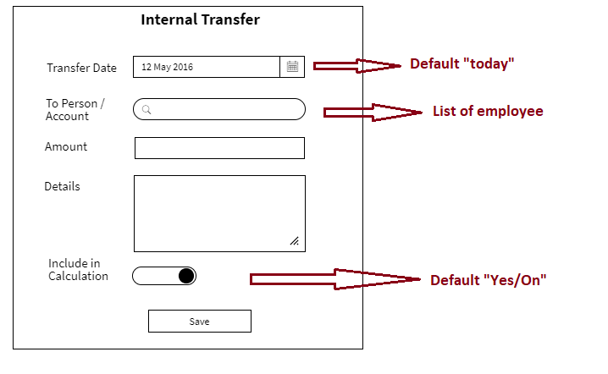

|  |  |  |
| --- | --- | --- |
| **Field** | **Validations** | **On Action** |
| Transfer Date* | 1. Not Empty 2. default “today” | Save |
| To Person/Account | Not Empty |
| Amount | 1.Not Empty  2.Numbers only |  |
|  |  |  |
| Include in calculation | Default “Yes/On” |  |
|  |  |  |

|  |  |  |
| --- | --- | --- |
| **On Action** | **What to do** | **API to use** |
| To Person/Account – Search | User Type 2 characters and auto-search starts and shows the list of employee’s accounts  Search on Account |  |
| Save | Create InternalTransfer |  |
|  |  |  |

## List Internal Transfer

|  |
| --- |
| **Tue Mar 31, 2020 4200.0**  **From:** Nilesh Yadav  **To:** Nilesh Yadav  **Details:** Galla |
| **Wed Apr 01, 2020 8200.5**  **From:** Ashok Suradakar  **To:** Avinash Yadav  **Details:** Galla |

## Create Employee

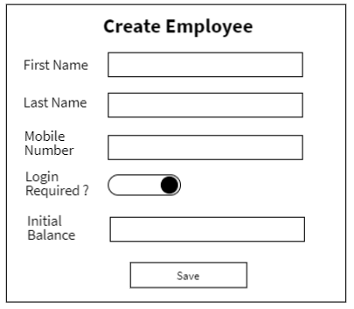

|  |  |  |
| --- | --- | --- |
| **Field** | **Validations** | **On Action** |
| First Name* | Not Empty – atleast 2 characters | Save |
| Mobile Number* | Not Empty – 10 digit number |
| Initial Balance | Number |

|  |  |  |
| --- | --- | --- |
| **On Action** | **What to do** | **API to use** |
| Save | Create Employee |  |

## List Employee

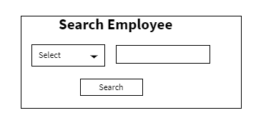

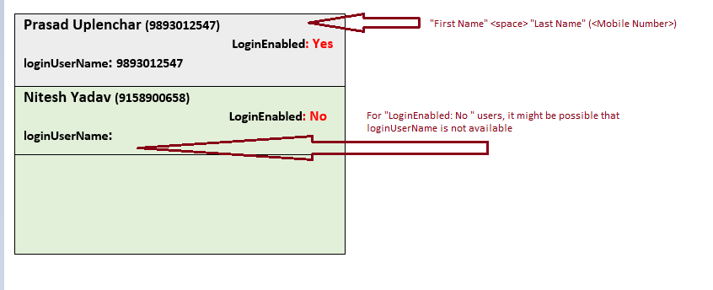

## Create Salary

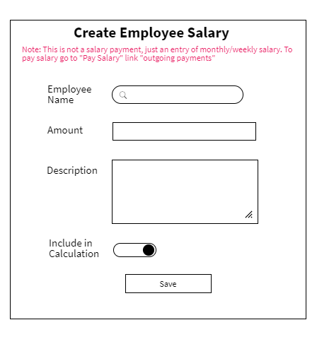

|  |  |  |
| --- | --- | --- |
| **Field** | **Validations** | **On Action** |
| Employee Name* | 1. Not Empty | Save |
| Amount | 1.Not Empty  2.Numbers only |  |
| Description | 1.Not Empty |  |
| Include in calculation | Default “Yes/On” |  |

|  |  |  |
| --- | --- | --- |
| **On Action** | **What to do** | **API to use** |
| Employee Name – Search | User Type 2 characters and auto-search starts and shows the list of employee |  |
| Save | Create an Employee |  |

## Salary Transfer

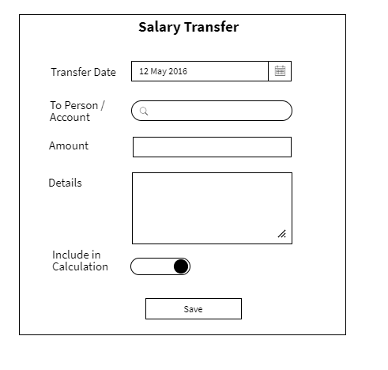

|  |  |  |
| --- | --- | --- |
| **Field** | **Validations** | **On Action** |
| Transfer Date* | 1. Not Empty 2. default “today” | Save |
| To Person / Account* | Not Empty |  |
| Amount* | 1.Not Empty  2.Numbers only |  |
| Include in calculation* | Default “Yes/On” |  |

|  |  |  |
| --- | --- | --- |
| **On Action** | **What to do** | **API to use** |
| To Person / Account – Search | User Type 2 characters and auto-search starts and shows the list of employee |  |
| Save | Create a Salary Transfer |  |

## List Salary

|  |
| --- |
| **Prasad Uplenchar (9893012547)**    **Date: Tue April 3, 2020**  **Salary: 15000.0**  **Description:** For Month of March 2020  **IncludeInCalculation:** Yes |
| **Nitesh Yadav (9158900658)**  **Date: Tue April 2, 2020**  **Salary: 15000.0**  **Description:** For Month of March 2020  **IncludeInCalculation:** Yes |

## List Salary Paid

|  |
| --- |
| **Prasad Uplenchar (9893012547)**    **Paid Date: Tue April 3, 2020**  **Amount: 15000.0**  **Paid By:** Nilesh Yadav  **Description:** For Month of March 2020  **IncludeInCalculation:** Yes |
| **Nitesh Yadav (9158900658)**  **Paid Date: Tue April 2, 2020**  **Paid Amount: 15000.0**  **Paid By:** Nilesh Yadav  **Description:** For Month of March 2020  **IncludeInCalculation:** Yes |

## Appendix

## List Salary Paid

<https://wireframepro.mockflow.com/editor.jsp?editor=on&bgcolor=white&perm=Create&ptitle=Test&category=form&projectid=M2842c70ddeae32ebe7ec3bebea90bc331585569701819&publicid=45c69ca06e1a4a2292e66f6ba5efac72#/page/D53ecf8202f75dfdff308076c6b85a1cf>

|  |
| --- |
| **ABC Enterprises** Mhow (23ASPRXXXXXX12)  **9158900354 +10,256**  **9157854698**  **Transport:** 166/8, New Loha Mandi Indore  **Billing:** Galla No. 120, Industrial State, Wagholi Pune - 400124 |
| **XYZ Corporation** Pune (26ASPRXXXXXX12)  **9145900654 -8,000**  **9157854789**  **Transport:** 127/8, Trasnport Nagar Pimpri PCMC  **Billing:** Shop 121, Industrial State, Chickli PCMC – 400258 |

Delivery

|  |
| --- |
| **ABC Enterprises** Mhow (23ASPRXXXXXX12)  **Tue Mar 31, 2020**    **Details:** 4 Computer, 2 mouse, 1 CPU |
| **XYZ Corporation** Pune (26ASPRXXXXXX12)  **Wed Apr 01, 2020**  **Details:** 4kg Hypochloride , 2ltr Clorine |
|  |

**Bill**

|  |
| --- |
| **ABC Enterprises** Mhow (23ASPRXXXXXX12)  **Tue Mar 31, 2020 3300.0**  CGST: 0.0 , SGST: 0.0, IGST: 0.0, Net: 3300.0 Extra:0.0  **Notes:** 4 Computer, 2 mouse, 1 CPU  **Include in CA Report: Yes**  **Include in Calculation: No**  **Bill No:** **C102** |
| **XYZ Corporation** Pune (26ASPRXXXXXX12)  **Wed Apr 01, 2020 5810.5**  CGST: 900.0 , SGST: 900.0, IGST: 0.0, Net: 5000.0 Extra:10.5  **Notes :** 4kg Hypochloride , 2ltr Clorine  **Include in CA Report: No**  **Include in Calculation: Yes**  **Bill No:** |

Expense List:

|  |
| --- |
| **Foo Enterprise Pune**  Machine maintenace  **Tue Mar 31, 2020 1200.0**  **Description:** Machinery maintenance parts purchased  **Include in Calculation: No**  **Include in CA Report: Yes** |
| **Bar Corporation Indore**  Transportation  **Wed Apr 01, 2020 4200.5**  **Description :** Transporting of the material  **Include in Calculation: Yes**  **Include in CA Report: No** |

**Employee**

|  |
| --- |
| **Prasad Uplenchar (9893012547)**  **Company Balance : -11,000.0**  **LoginEnabled: Yes**  **loginUserName: 9893012547**  **Salary To be Paid: 9000.0** |
| **Nitesh Yadav (9158900658)**  **Company Balance: 1,9,0000.0**  **LoginEnabled: Yes**  **loginUserName: 9158900658**  **Salary To be Paid: 9000.0** |

**Payments**

|  |
| --- |
| **Foo Enterprise Pune**  **Tue Mar 31, 2020 4200.0**  **Received By:** Nilesh Yadav  **Details:** Raw material |
| **Bar Corporation Indore**  **Wed Apr 01, 2020 8200.5**  **Received By:** Ashok Suradakar  **Details:** Raw material |

List Vendor Invoices

|  |
| --- |
| **National Chemical Ltd.** Ahmadabad  **Tue Mar 31, 2020 3300.0**  Net: 3300.0, CGST: 0.0 , SGST: 0.0, IGST: 0.0, Extra:0.0  **Notes:** 4kg Hypochloride , 2ltr Clorine  **Include in Calculation: No**  **Include in CA Report: Yes**  **Bill No: C103** |
| **Aardhya Agro Ltd** Pune  **Wed Apr 01, 2020 5810.5**  Net: 5000.0 , CGST: 900.0 , SGST: 900.0, IGST: 0.0, Extra:10.5  **Notes :** 4 Computer, 2 mouse, 1 CPU  **Include in Calculation: Yes**  **Include in CA Report: No**  **Bill No:** |

List Vendor Payments

|  |
| --- |
| **National Chemical Ltd.** Ahmadabad  **Tue Mar 31, 2020 3300.0**  **Done By:** Nilesh Yadav  **Details:** Raw material |
| **Aardhya Agro Ltd** Pune  **Wed Apr 01, 2020 5810.5**  **Done By:** Ashok Suradakar  **Details:** Raw material |

List Salary

|  |
| --- |
| **Prasad Uplenchar (9893012547)**    **Date: Tue April 3, 2020**  **Salary: 15000.0**  **Description:** For Month of March 2020 |
| **Nitesh Yadav (9158900658)**  **Date: Tue April 2, 2020**  **Salary: 15000.0**  **Description:** For Month of March 2020 |

